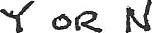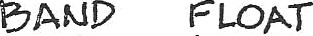District Line Up that. District

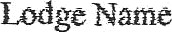
Numbet Exalted RuJet
cfc.M c

4.

5.

9.

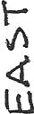 12.

t3.

Complete arid returns to Chairman no later than April ZOO2f'2f ... Please prirrt clearly.

