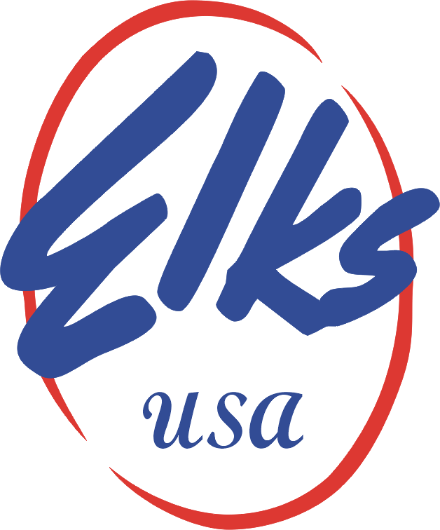
New Jersey State Elks
STEVE HOLLER , STATE CHAIR PARADES
RETURN TO : DOUG PEARSON REGION 1
285 GRANDVIEW ave EDISON NJ 08837
dough5161@gmail.com

CAR SIGN FORM
PLEASE PRINT CLEARLY
NO HOMEMADE SIGNS PLEASE
LODGE OR DISTRICT AMBASSADOR

NAME OF CHILD__________________________________

ELK YEAR_______________________________________

SPONSOR LODGE NUMBER_________________________

OR DISTRICT SPONSOR____________________________

PLEASE SUBMIT A CHECK PAYABLE TO THE NJSEA FOR $35.00 WITH THIS FORM. THIS COVERS THE COST OF 2 SIGNS FOR THE CAR, WHICH ARE PROFESSINALLY MADE, WEATHER PROOOF, AND REUSALBLE. THIS NEEDS TO BE IN THE HANDS OF THE STATE PARADES CHAIR PERSON
NO LATER THAN APRIL 19,2022

