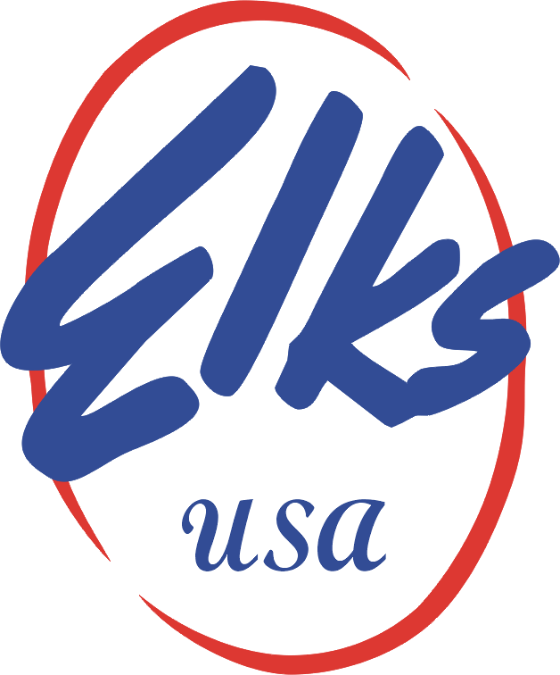
New Jersey State Elks
STEVE HOLLER, PARADES STATE CHAIR
RETURN TO : DOUG PEARSON REGION 1
285 GRANDVIEW ave, EDISON , N.J. 08837
dough5161@gmail.com

2022 DISTRICT PARADE MARSHALL UNIFORM FORM

DISTRICT___________________________________________
DISTRICT CHAIR_____________________________________
DISTRICT CHAIR WILL DELIVER YOU HAT&SHIRT TO YOU
SIZES
INDICATE THE QUANITY NEXT TO THE SIZE WANTED
SM______MED______LG______XL______XX______XXX_____
EACH SET is $25.00 with EXTRA $3.00 for XX&XXX
THESE UNIFORMS CAN BE USED FOR MANY YEARS.
TOTAL AMOUNT FOR ORDER $___________
MAKE CHECK PAYABLE TO NJSEA, MAIL FORM AND CHECK TO STATE COORDINATOR
NO LATER THAN APRIL 19, 2022

